

# **Project Report (CST1510)**

**Programming for Data Communication and Networks**

**Mr. Santhosh Menon**

Aisha Mahmood Nyako

M01027193

**Project Report**

**Name:** Aisha Mahmood Nyako

**Student ID:** M01027193

**Program:** Cybersecurity and Digital Forensics

**GitHub Repository:** <https://github.com/aishamhn/CW2_CST1510>

**Disclaimer**

It is important to disclose that AI tools were utilized for debugging errors, organizing code structure, and clarifying complex technical concepts throughout this project.

**Introduction**

A Multi-Domain Intelligence Platform is a system that combines, analyses, and visualizes data from multiple disconnected areas (domains) of an organization. Its primary purpose is not just to let users edit data **(CRUD),** but to also generate insights and spot patterns regarding security threats or operational issues.

The Multi-Domain Intelligence Platform's job is straightforward. It basically acts as the central hub that makes sense of data from different parts of a company. It also helps integrate data and finds hidden risks. I chose to do all 3 domains (Cybersecurity, Data Science and IT Operations) which is tier 3. However, Only the Cybersecurity tab allows the user to perform CRUD operations while the other two are read only.

**How I Built the System**

I began my project in Week 7 by creating a very simple login and sign-up application that ran directly in the terminal using a file called ‘authorization.py’. I used **Bcrypt** to hash passwords because it’s much safer than simple encryption. When a user logs in, the system hashes their entered password and only compares the two hashes. At this stage, I just stored the usernames and passwords in a file called ‘users.txt’.

In Week 8 we started learning about Databases and **SQL**. This made me realise that storing passwords even if they’re hashes, in a basic text file is not secure at all and it would be better to store it in a table in a database. The lab document gave us a lot of the code and the file structure for the new database setup. I copied the file structure and code, but I kept running into errors and confusion trying to connect everything properly.

I used AI tools here to figure things out and debug the issues. Eventually, I managed to migrate all the old users in the ‘users.txt’ file over to the new SQL database. I created tables for the users and downloaded the csv files for all three domains (Cyber Incidents, IT Tickets, and Datasets).

I then created all the necessary files for the **CRUD** functions. Initially, I just ran test CRUD functions in the terminal, but I hadn't yet created a way for a user to actually perform CRUD operations.

In week 9,we started using **streamlit.** I created the main file, ‘app.py’. I then stopped using the command-line terminal to run my application because I could now use a browser. I then implemented different pages for navigation, used the sidebar, and added simple charts.

**The System Structure**

A user interacts with the Streamlit Web Interface (e.g the Login Page)

The Streamlit page calls a specific function in the data files (e.g insert_incident or get_all_incidents)

The data is then sent back up to the Streamlit interface and displayed

These functions connect to the SQLite database . They then execute an SQL query (like INSERT or SELECT) or receive data

The entire application runs on this structure. It moves information from user input to the database and back again to display the results.

**Code Organization**

Since I wasn't present in the Week 11 lecture, I chose not to use classes in my code as I didn't get to fully grasp how to properly implement it. Instead, I focused on a modular, function-basedapproach to keep the code organised. I used:

* **UI Files (pages/)**: These are all the Streamlit files (like login.py, dashboard.py). Their main job is to handle the user interface and call specific data functions.
* **Data Files (app/data/)**: These contain all the functions that talk directly to the database (e.g incidents.py, tickets.py). All the SQL and connection code is kept here.
* **Service Files (app/services/)**: These files hold the functions for hashing/login or the AI integration.

My dashboard initially just showed read only data from the database. The lecturer pointed out that I wasn't actually letting the user create, update, or delete anything. I fixed it and implemented the full user input CRUD functions for the **cyber security tab** only.

My visualizations are placed directly on the dashboard tabs.

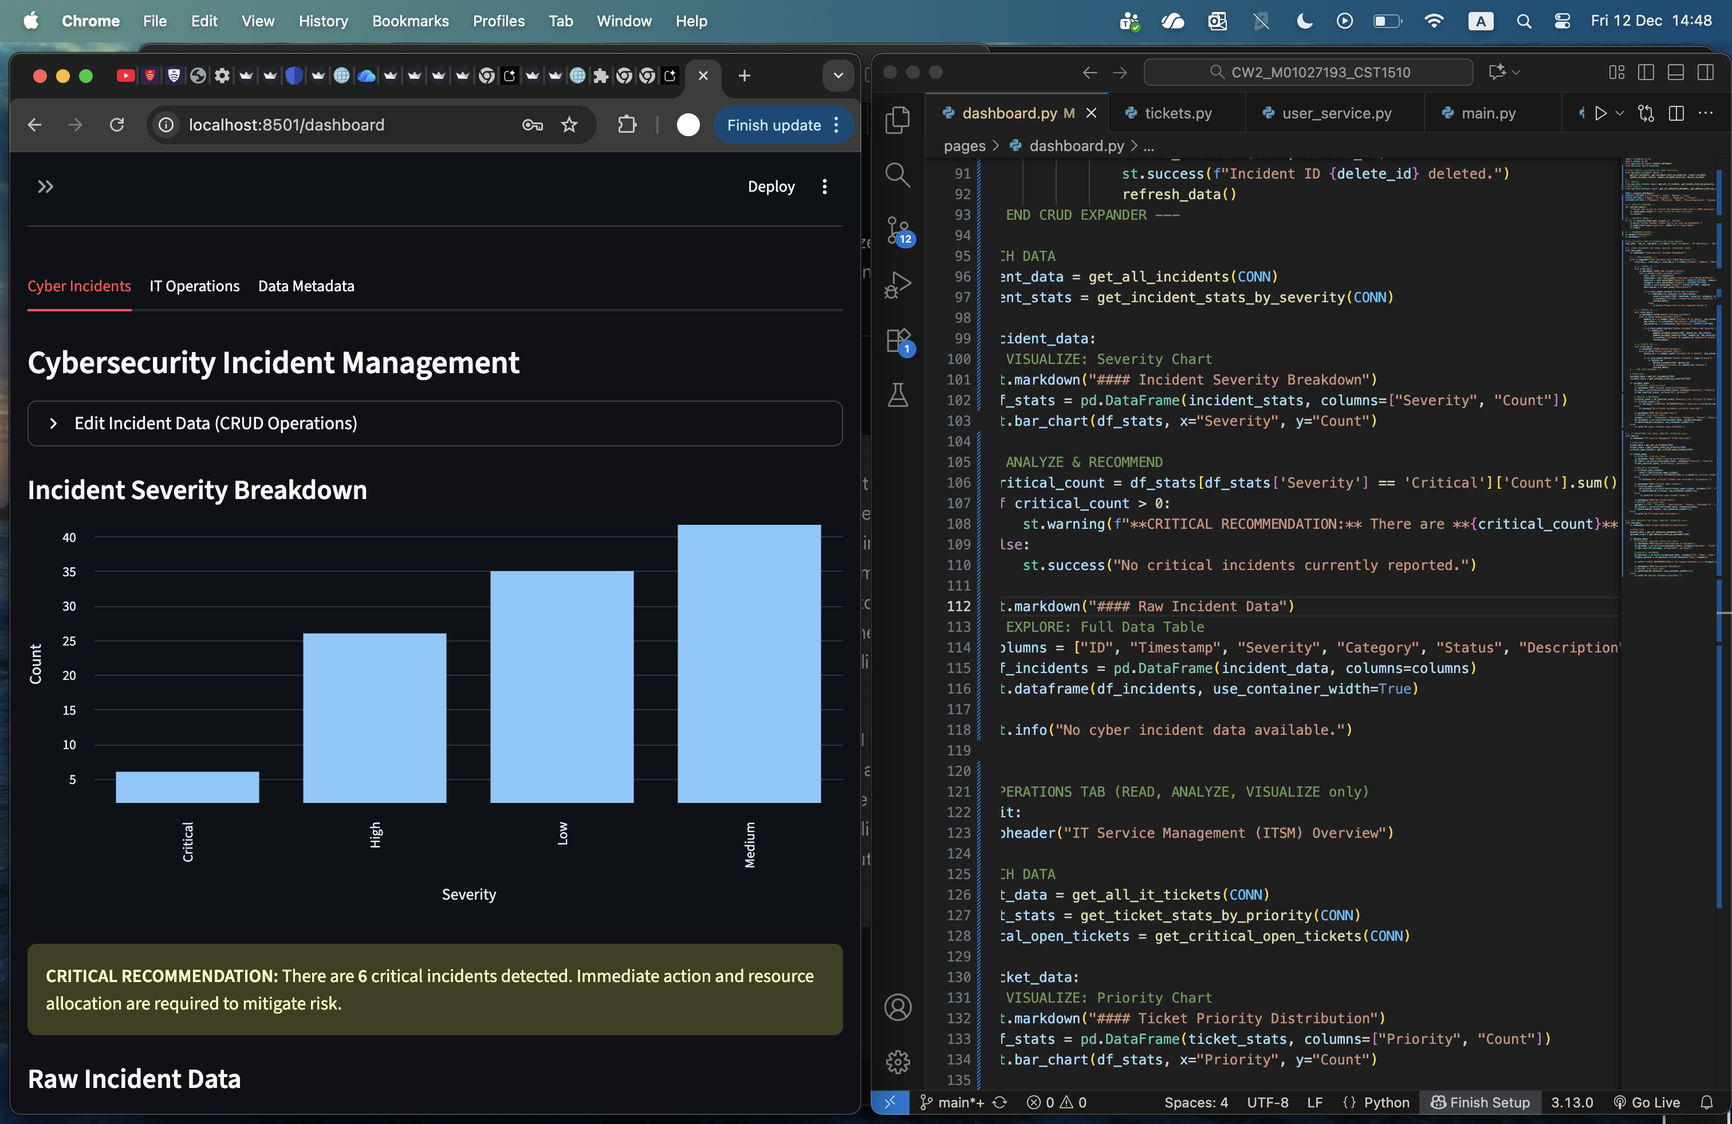

* The **Cyber Security** Tab shows a Bar Chart of incident counts grouped by Severity. The data is ordered by risk level, not just count. This gives the user an idea of the most serious problems. This tab also has an alert box if any critical incidents exist.

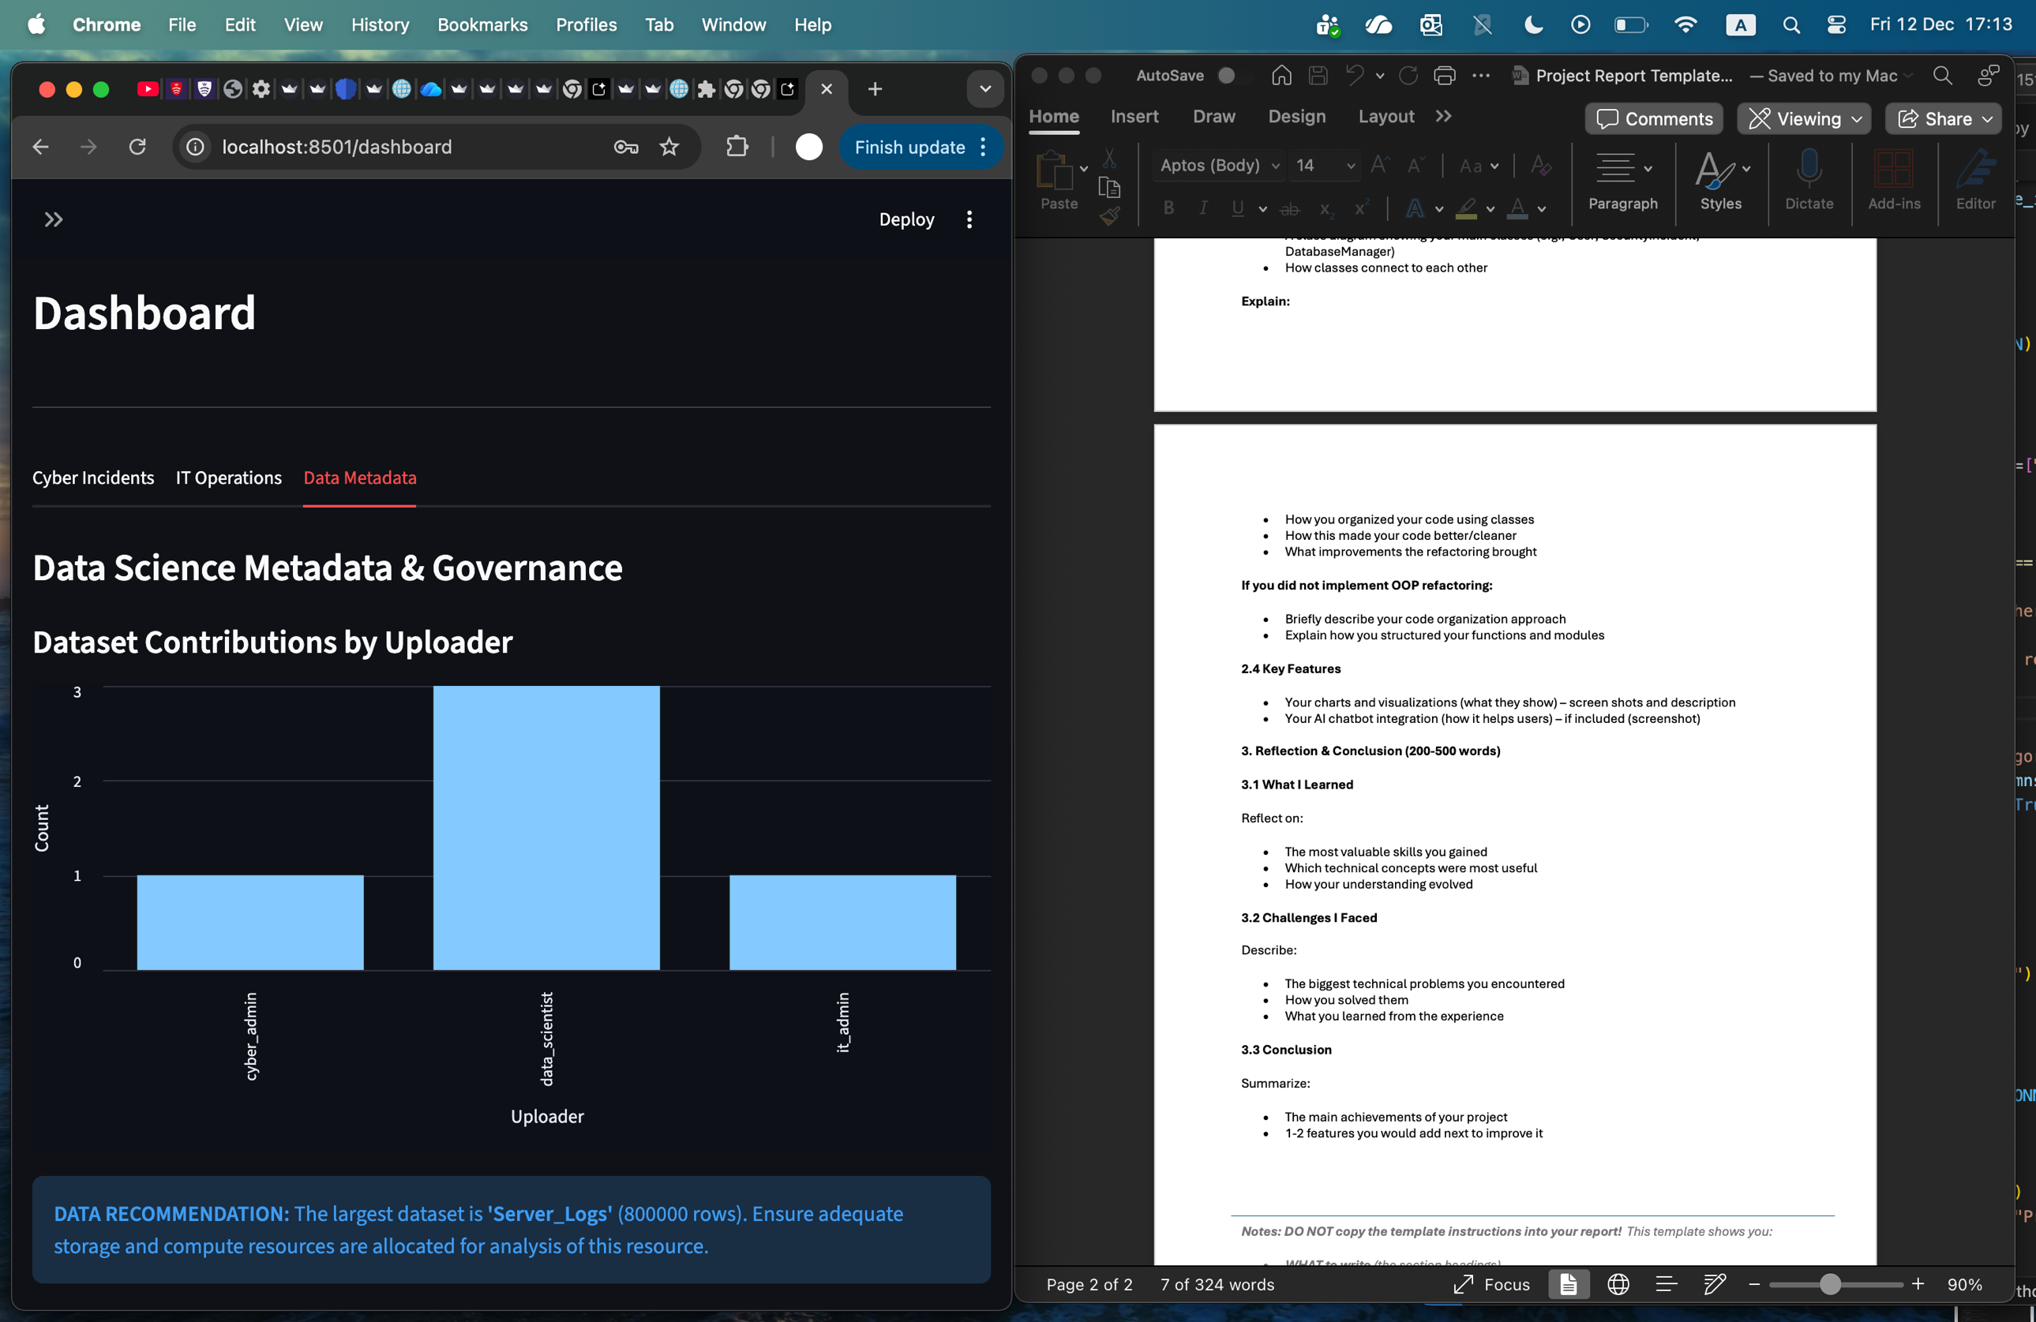

* The **Data Science Metadata** tab is also read only. It has a Bar Chart visualizing the dataset contributions by Uploader to track ownership and activity. It also has an alert box that identifies the largest dataset by rows and provides a recommendation for resource allocation.

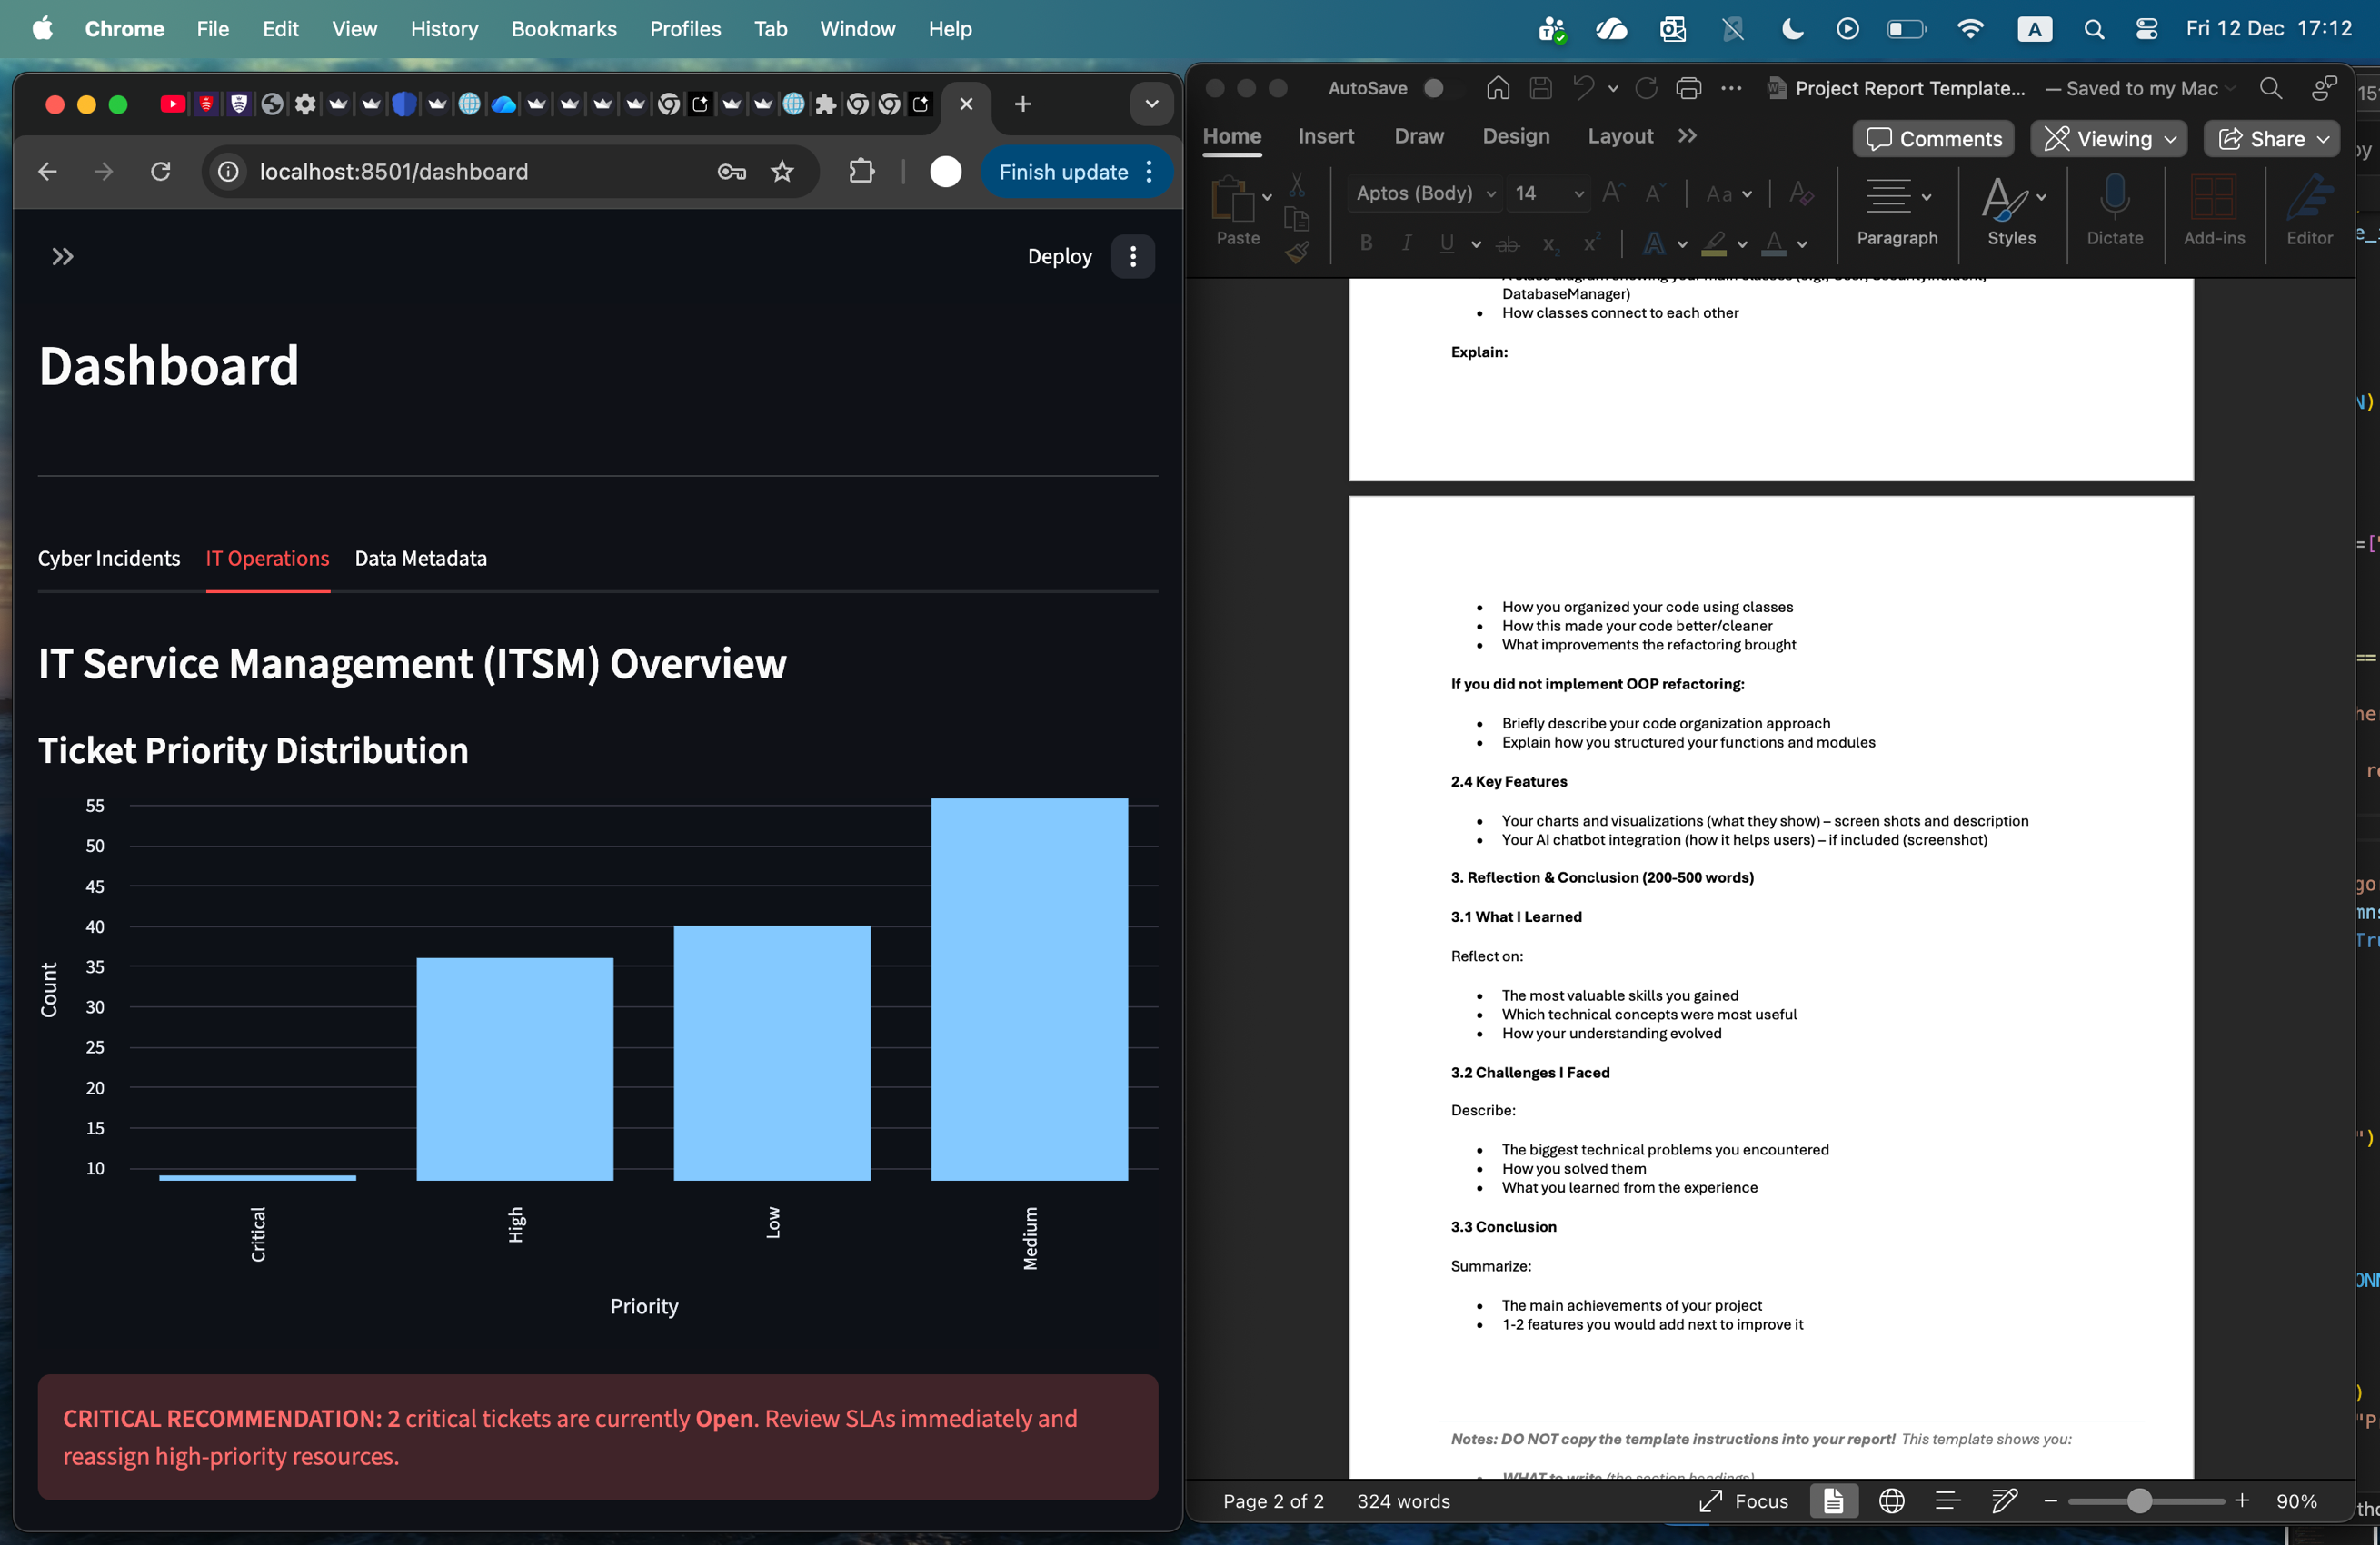

* The **IT Operations** tab is read only. It displays a Bar Chart of tickets grouped by **Priority**, ordered by risk. There is also an alert box that provides a recommendation if any Critical tickets are currently Open.

In Week 10/11, I managed to integrate the Google **Gemini AI** into my system. This involved creating two new files. one file (ai_service.py) imported the AI and gave it instructions to act as a multi-domain intelligence assistant. The other file (ai_chat.py) built the graphical page for the chat inside Streamlit. The AI feature is fairly basic right now. I really wanted it to be more connected with the database so that it could analyse specific data and give recommendations, but I got a technical issue and decided to keep it as a standalone assistant.

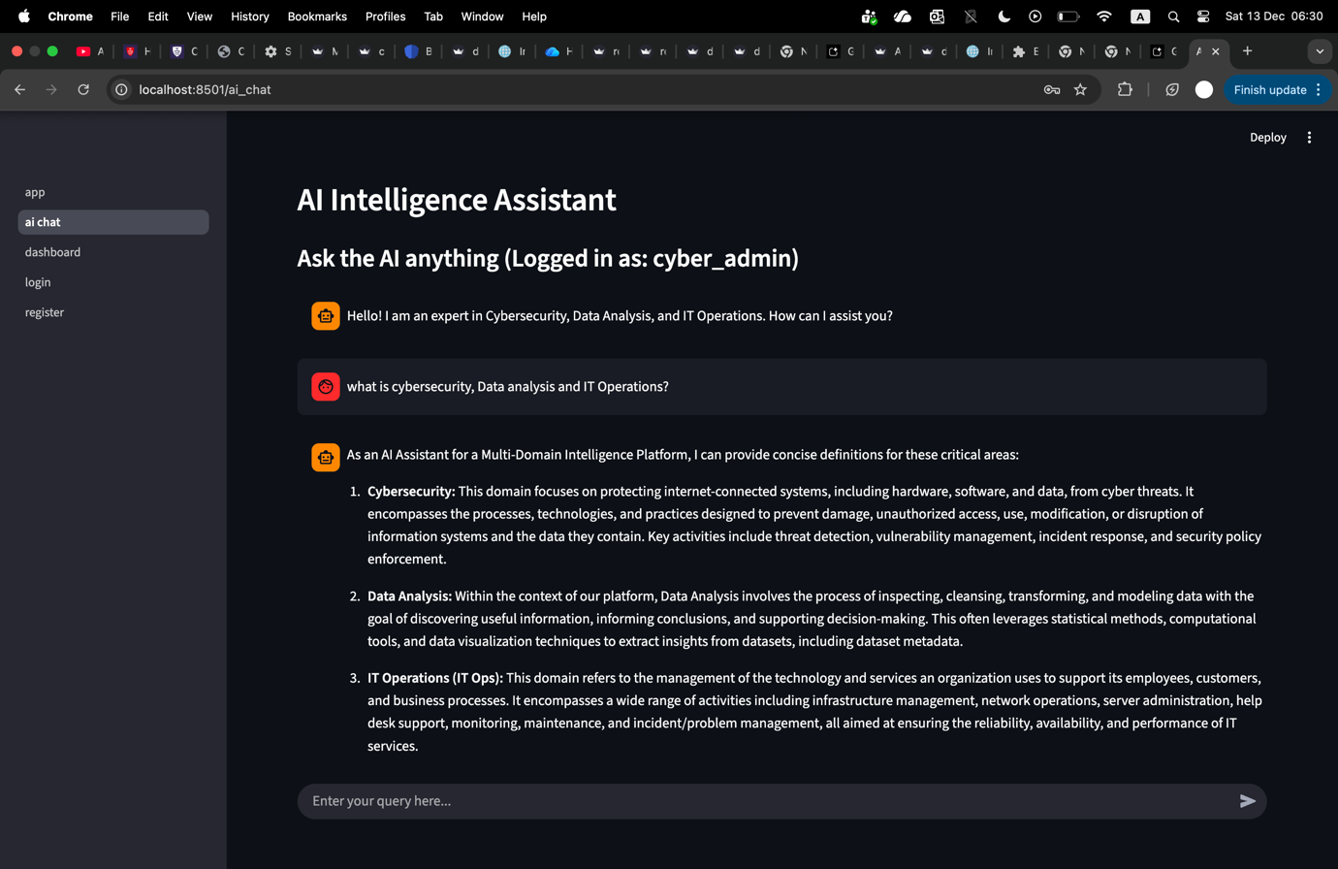

**Reflection & Conclusion**

Over the five weeks of working on this project, I can definitely say that it has been interesting and stressful. Outside of coding skills, I’d say the most valuable skill I gained is time management. The project pushed me to be more organized and disciplined with my tasks. It forced me to work effectively both inside and outside of university hours. I learned how to use various new modules like **Bcrypt, SQLite** and **Streamlit.** I also gained a basic understanding of GitHub. However, I definitely need more time exploring GitHub to fully get the hang of it. More broadly, my understanding of the theoretical concepts behind how applications and platforms work has deepened significantly. I learned how to turn simple code that ran in the terminal, into a fully functional GUI platform. I also never truly realized how AI was integrated into a piece of software until now, which felt incredible to implement. This entire process allowed me to build directly upon the foundational knowledge I gained from IFP.

I did feel quite stressed, especially during the first few weeks. In my opinion, the jump from Project 1 to Project 2 was quite massive. We went from writing simple code to attempting a whole Intelligence Platform. Because of this complexity, AI became a crucial helping hand in my project, and this experience taught me how to do efficient AI prompting to solve problems. I also feel that my understanding advanced more on the theoretical side than the practicaltechnical side of building the project. This is because most of the code was provided within the lab tasks, which led to a lot of copying and pasting and, frankly, confusion. It felt like we would get a good introduction to the basic concept and code, but then the lab task itself would be much more complicated than the initial lesson. I faced a technical issue when trying to link the AI to the database to give more insightful recommendations. I eventually decided to keep the AI as a standalone assistant. I also ran into an issue where my API key had gotten exposed. I fixed that by moving the API key into a secret file called “**secrets.toml**”.

All in all, this experience has been truly transformative when it comes to understanding the functionality of applications, the importance of security, and using GitHub. However, I plan to do more individual studying because the process of learning the concepts felt a bit rushed. The main achievement of this project is definitely a deepened understanding of complex systems, and the importance of security in applications. The features I would like to improve on are my AI integration with the database so that it could be overall more useful. I would also like to implement classes in my code.